Object-oriented programming (OOP) is a computer programming model that organizes software design around data, or objects, rather than functions and logic.
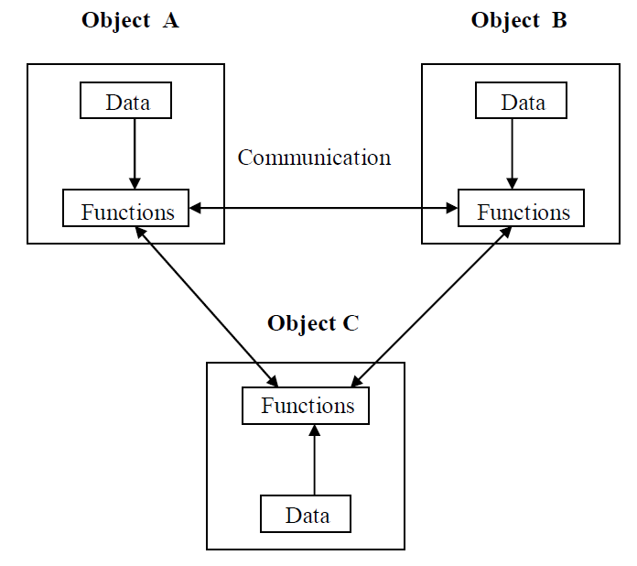
Features of the Object Oriented programming
1. programs are divided into what are known as objects.
2. Data structures are designed such that they characterize the objects.
3. Functions that operate on the data of an object are tied together in the data structure.
4. Data is hidden and can’t be accessed by external functions.
5. Objects may communicate with each other through functions.
6. Follows bottom-up approach in program design.

BASIC CONCEPTS OF OBJECTS ORIENTED PROGRAMMING

1. Objects
2. Classes
3. Data abstraction and encapsulation
4. Inheritance
5. Polymorphism
6. Dynamic binding
7. Message passing

OBJECTS
Objects are the basic run-time entities in an object-oriented system. They may represent a person, a place, a bank account, a table of data or any item that the program must handle.
The fundamental idea behind object oriented approach is to combine both data and function into a single unit and these units are called objects.
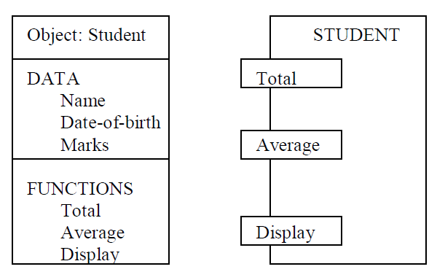

CLASS:
A group of objects that share common properties for data part and program part are collectively called as class.
In C ++ a class is a new data type that contains member variables and member functions that operate on the variables.
DATA ABSTRACTION :
Abstraction refers to the act of representing essential features without including the back ground details or explanations. Classes use the concept of abstraction and are defined as size, width and cost and functions to operate on the attributes.
DATA ENCAPSALATION :
The wrapping up of data and function into a single unit (called class) is known as encapsulation. The data is not accessible to the outside world and only those functions which are wrapped in the class can access it. These functions provide the interface between the objects data and the program.
INHERITENCE :
Inheritance is the process by which objects of one class acquire the properties of another class. In the concept of inheritance provides the idea of reusablity. This mean that we can add additional features to an existing class without modifying it.
POLYMORPHISIM:
Polymorphism means the ability to take more than one form. An operation may exhibit different instance. The behavior depends upon the type of data used in the operation.
DYNAMIC BINDING :
Binding refers to the linking of a procedure call to the code to the executed in response to the call. Dynamic binding means the code associated with a given procedure call is not known untill the time of the call at run-time. It is associated with a polymorphic reference depends upon the dynamic type of that reference.
MESSAGE PASSING :
An object oriented program consists of a set of objects that communicate with each other.

Basics of C++

C ++ is an object oriented programming language, C ++ was developed by Jarney Stroustrup at AT & T Bell lab, USA in early eighties. C ++ was developed from c and simula 67 language. C ++ was early called ‘C with classes’.
C++ Comments:

C++ introduces a new comment symbol //(double slash).
The double slash comment is basically a single line comment. Multi line comments can be written as follows:
// this is an example of
// c++ program
// thank you
The c comment symbols /* ….*/ are still valid and more suitable for multi line comments.
/* this is an example of c++ program */
Output Operator:

The statement cout <<”Hello, world” displayed the string with in quotes on the screen. The identifier cout can be used to display individual characters, strings and even numbers. It is a predefined object that corresponds to the standard output stream. The cout object, whose properties are defined in iostream.h represents that stream. The insertion operator << also called the ‘put to’ operator directs the information on its right to the object on its left.
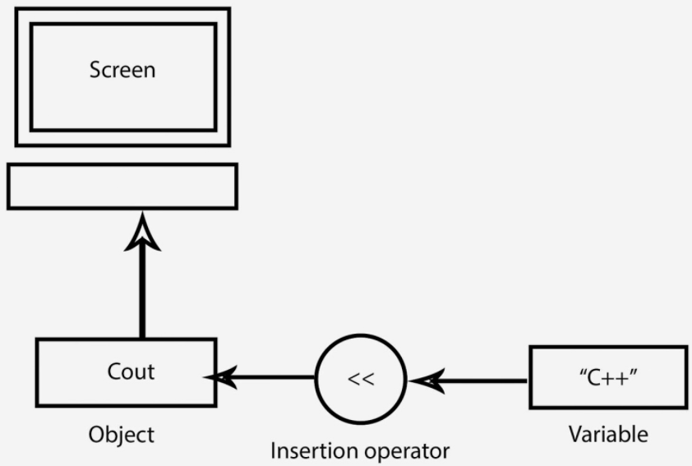
Input Operator:
The statement
cin>> number 1;
is an input statement and causes. The program to wait for the user to type in a number. The number keyed in is placed in the variable number1. The identifier cin is a predefined object in C++ that corresponds to the standard input stream. Here this stream represents the key board.
The operator >> is known as get from operator. It extracts value from the keyboard and assigns it to the variable on its right.
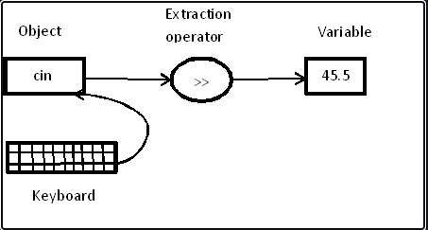

Cascading Of I/O Operator:

cout<<”sum=”<<sum<<”\n”;
cout<<”sum=”<<sum<<”\n”<<”average=”<<average<<”\n”;
cin>>number1>>number2;

A Simple C++ Program
#include<iostream> //include header file
using namespace std;
int main()
{
cout<<"Hello world "; //output statement
}
Output: Hello world
#include <iostream>

This directive causes the preprocessor to add the contents of the iostream file to the
program.
Namespace is a new concept introduced by the ANSI C++ standards committee. This defines a scope for the identifiers that are used in a program.

int main ()
This line corresponds to the beginning of the definition of the main function. The main function is the point by where all C++ programs start their execution, independently of its location within the source code.

Output Statement:
cout<<"Hello world";
This line is a C++ statement. A statement is a simple or compound expression that can actually produce some effect. In fact, this statement performs the only action that generates a visible effect in our first program.

Let us add an additional instruction to our first program:
// my second program in C++
#include <iostream>
using namespace std;
int main ()
{
cout << "Hello World! ";
cout << "I'm a C++ program";
return 0;
}
Output:-Hello World! I'm a C++ program
In this case, we performed two insertions into cout in two different statements. Once again, the separation in different lines of code has been done just to give greater readability to the program.

STRUCTURE OF C++ PROGRAM
1. Include files
2. Class declaration
3. Class functions, definition
4. Main function program
Example :-
# include<iostream>
using namespace std;
class person
{
char name[30];
int age;
public:
void getdata(void);
void display(void);
};
void person :: getdata ( void )
{
cout<<”enter name”;
cin>>name;
cout<<”enter age”;
cin>>age;
}
void person::display(void)
{
cout<<”\n name:”<<name;
cout<<”\n age:”<<age;
}
int main( )
{
person p;
p.getdata();
p.display();
return(0);
}

TOKENS:

The smallest individual units in program are known as tokens. C++ has the following tokens.
i. Keywords
ii. Identifiers
iii. Constants
iv. Strings
v. Operators

KEYWORDS:

The keywords implement specific C++ language feature. They are explicitly reserved identifiers and can’t be used as names for the program variables or other user defined program elements.
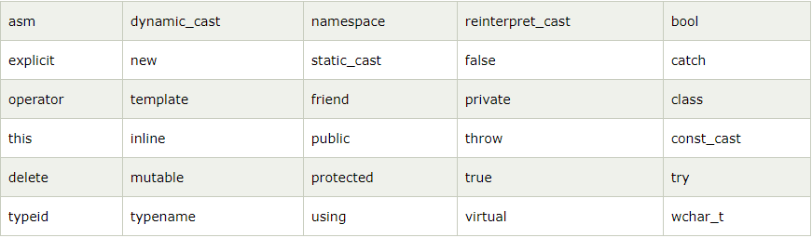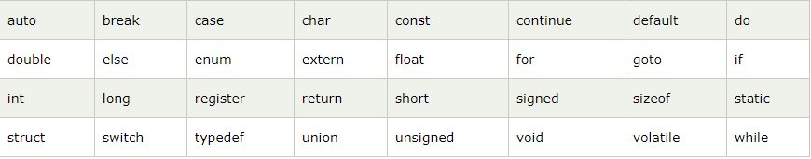

IDENTIFIERS:
Identifiers refers to the name of variable , functions, array, class etc. created by programmer. Each language has its own rule for naming the identifiers.
The following rules are common for both C and C++.
1. Only alphabetic chars, digits and under score are permitted.
2. The name can’t start with a digit.
3. Upper case and lower case letters are distinct.
4. A declared keyword can’t be used as a variable name.
BASIC DATA TYPES IN C++
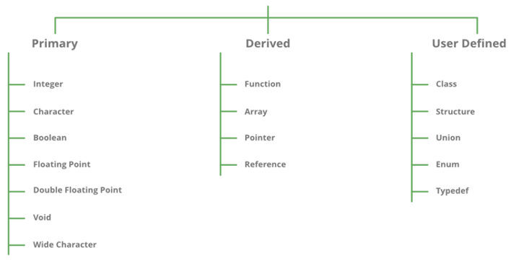
Declaration of Variables

The same rules of variable names are applicable in C++ as in C. C++ is also statically types i.e., variables must be declared before use.

Reference Variables

C++ introduces a new kind of variable known as the reference variable. A reference variable provides an alias (alternative name) for a previously defined variable. For example, if we make the variable sum a reference to the variable total, then sum and total can be used interchangeably to represent that variable. A reference variable is created as follows:

Data-type & reference variable = variable-name
Ex. int x=100;
int &y=x;
A reference variable must be initialized at the time of declaration.

Example
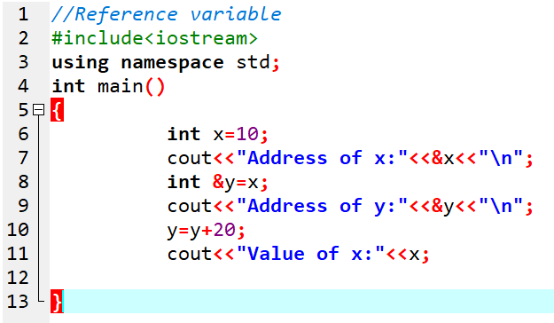
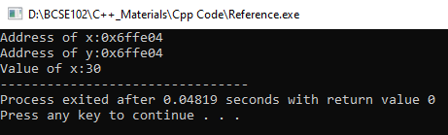

OPERATORS IN C++ :

C++ has a rich set of operators. All C operators are valid in C++ also. In addition. C++ introduces some new operators.
<< insertion operator
>> extraction operator
: : scope resolution operator
: :* pointer to member declarator
* pointer to member operator
.* pointer to member operator
Delete memory release operator
Endl line feed operator
New memory allocation operator
Setw field width operator

SCOPE RESOLUTION OPERATOR:
Like C,C++ is also a block-structured language. Block -structured language. Blocks and scopes can be used in constructing programs. We know same variables can be declared in different blocks because the variables declared in blocks are local to that function.
Blocks in C++ are often nested.
Example:
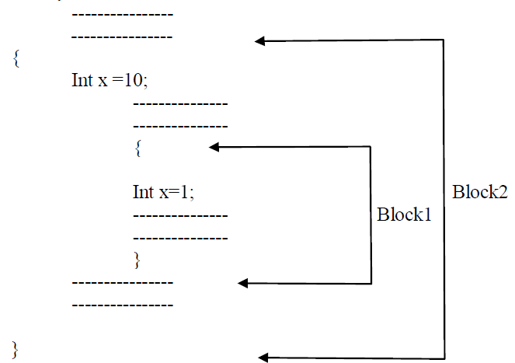
Block1 is contained in block 2 .Note that declaration in an inner block hides a declaration of the
same variable in an outer block and therefore each declaration of x causes it to refer to a different data object . Within the inner block the variable x will refer to the data object declared there in.
In C,the global version of a variable can't be accessed from within the inner block. C++ resolves this problem by introducing a new operator :: called the scope resolution operator .This can be used to uncover a hidden variable.
Syntax: : : variable_name;
Example:
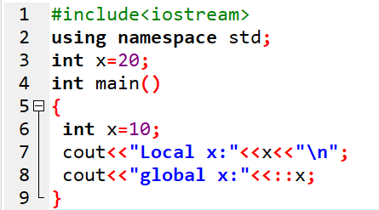
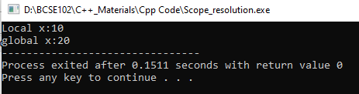

MANIPULATERS:

Manipulators are operator that are used to format the data display. The most commonly manipulators are endl and setw.
The endl manipulator, when used in an output statement, causes a line feed to be insert.(just like \n) .
setw C++ is a method of iomaip library present in C++. setw function is a C++ manipulator which stands for set width.

Example:
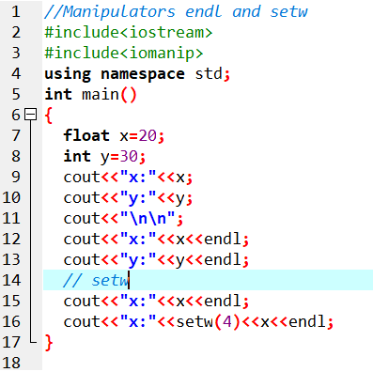
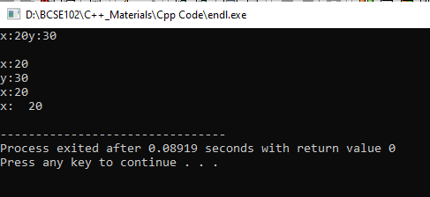

CONTROL STRUCTURES:
Like c,c++, supports all the basic control structures and implements them various control statements.

The if statement:

The if statement is impklemented in two forms:

1. simple if statement
2. if… else statement

Simple if statement:

if (condition)
{
Action;
}

If.. else statement

If (condition)
Statment1
else
Statement2

The switch statement

This is a multiple-branching statement where, based on a condition, the control is transferred to one of the many possible points;
Switch(expr)
{
case 1:
action1;
break;
case 2:
action2;
break;
..
..
default:
message
}

The while statement:
Syn:
While(condition)
{
Stements
}
The do-while statement:

Syn:

do
{
Stements
} while(condition);

The for loop:
for(expression1;expression2;expression3)
{
Statements;
Statements;
}

FUNCTION IN C++ :
A function is a group of statements that together perform a task.
Syntax:−
return_type function_name( parameter list )
{
body of the function
}

Call by Reference

Provision of the reference variables in C++ permits us to pass parameters to the functions
by reference. When we pass arguments by reference. The formal arguments in the called function become aliases to the 'actual' arguments in the calling function. This means that when the function is working with its own arguments, it is actually working on the original data.

In traditional C, this is accomplished using pointer.

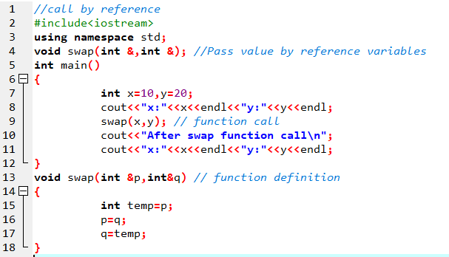
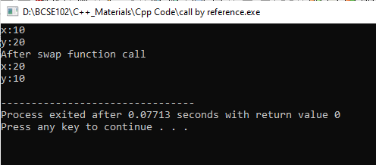

Return by Reference

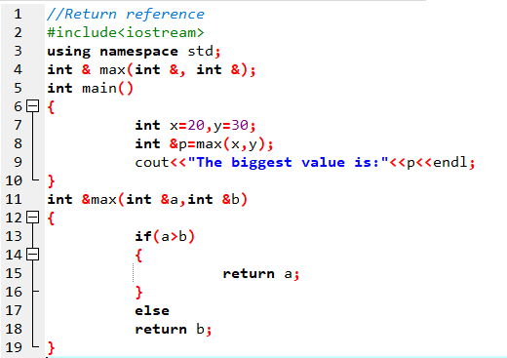
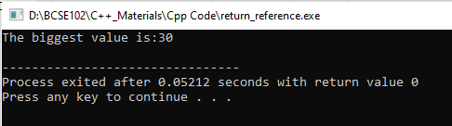
Inline functions

When the program executes the function call instruction the CPU stores the memory address of the instruction following the function call, copies the arguments of the function on the stack and finally transfers control to the specified function. The CPU then executes the function code, stores the function return value in a predefined memory location/register and returns control to the calling function. This can become overhead if the execution time of function is less than the switching time from the caller function to called function (callee). For functions that are large and/or perform complex tasks, the overhead of the function call is usually insignificant compared to the amount of time the function takes to run. However, for small, commonly-used functions, the time needed to make the function call is often a lot more than the time needed to actually execute the function’s code. This overhead occurs for small functions because execution time of small function is less than the switching time.

C++ provides an inline functions to reduce the function call overhead. Inline function is a function that is expanded in line when it is called. When the inline function is called whole code of the inline function gets inserted or substituted at the point of inline function call.
The syntax for defining the function inline is:
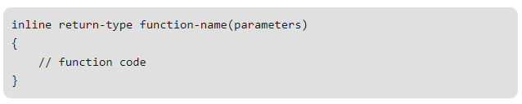
Remember, inlining is only a request to the compiler, not a command. Compiler can ignore the request for inlining. Compiler may not perform inlining in such circumstances like:
- If a function contains a loop. (for, while, do-while)
- If a function contains static variables.
- If a function is recursive.
- If a function return type is other than void, and the return statement doesn’t exist in function body.
- If a function contains switch or goto statement.

#include<iostream>
#include<ctime>
using namespace std;
inline void cube(int x)
{
cout<< x*x*x << endl;
}
int main()
{
int start_s=clock();
cube(10);
int stop_s=clock();
cout << "time: " << (stop_s-start_s)/double(CLOCKS_PER_SEC)*1000 << endl;
}
Output:
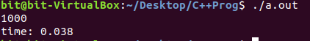
Output of the same program without Inline function:
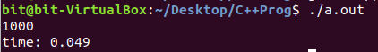

Default Arguments
- A default argument is a value provided in function declaration that is automatically assigned by the compiler if caller of the function doesn’t provide a value for the argument with default value
- Always default arguments must be at the end of the argument list
- C++ allows us to call a function without specifying all its arguments.
- In such cases, the function assigns a default value to the parameter which does not have a matching argument in the function call.
- Default values are specified when the function is declared or function defined.

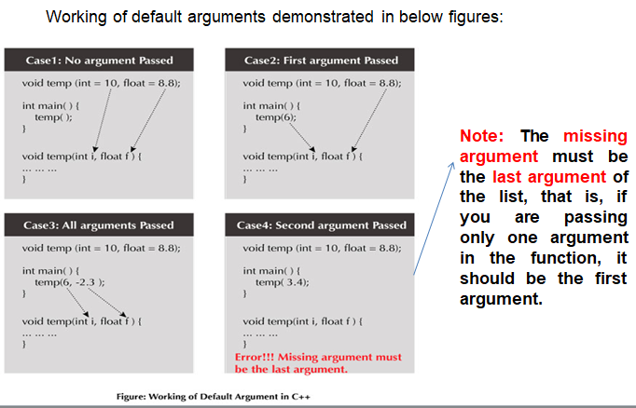
Example
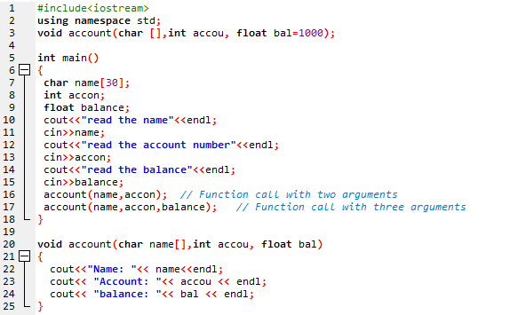

Output:
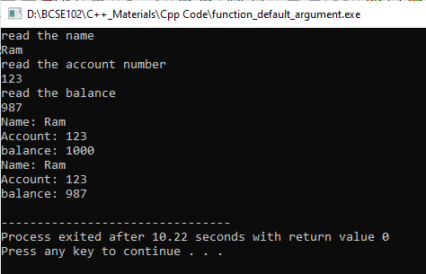

More problems
- Employee performance evaluation process VIT University has taken a decision to performance evaluation salary of the employee on January month as follows:
If the total experience is more than 15 years then 10% hike to the existing salary. Otherwise 5% hike to the existing salary. Write a program to display the revised January month salary of the employee using inline function.

- A police camp is recruiting the trainees by measuring the parameters such as height, age and chest. The selection based on the following conditions:
- Height should be between 5.2 to 5.6 inches
- Age should be greater than 18 and less than 25
- Chest should be greater than 45 cm
Write a inline function to find whether the person is fit to the police or not.

- A electronic shop has given the offer during pongal festival of 3% on every item purchase. The prices of the electronic items are Hp laptop is Rs. 35000/-, HP laptop charger is Rs. 1500/-, and Hp head set is Rs. 250/-.Write a default function to calculate the total bill amount to pay for purchase in electronic shop.

- A tractor rental shop has three plans. In the first plan, you can rent the tractor Rs. 100 per hours. In second plan, you can rent the tractor Rs.500 for the first 6 hours and Rs.90 per extra hour. In third plan Rs 1000 for the first 12 hours and Rs80 per extra hour. Write a inline function to suggest the best plan to the farmer customer based on the given the number of hours to use the tractor in their garden.

- Assume that in a banking operation scenario, you are making a fund transfer operation from one account to the other of the same bank and branch. Here after transaction, the balance amount field in both the objects should be updated, i.e. debit should happen in source account and credit should happen in destination account which in turn update the balance amount field of both the objects.

